**Data visualisation Final Project**

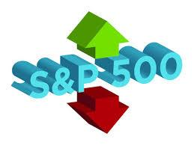

**Stock market analysis**



**The project is about stock market analysis there are 3 data set ,About the American Stock Exchange,**

## S&P 500 component stocks

**First data include 2 table**

**First table** about US stock index s&p, it’s come on short Standard & Poor's, is a company well known around the world as a creator of financial market indices—widely used as investment benchmarks—a data source, and an issuer of [credit ratings](https://www.investopedia.com/terms/c/creditrating.asp) for companies and debt obligations. It's perhaps best-known for the popular and often-cited [S&P 500 Index](https://www.investopedia.com/terms/s/sp500.asp). The company's roots date back to the 1860s. Since 2016, its official corporate name has been S&P Global,Standard & Poor's grew out of two companies: Poor's Publishing, a publisher of railroad industry guidebooks officially founded in 1868, and the Standard Statistics Bureau (later Company), founded in 1906, which published financial data on companies. In 1923, it released its first stock market indicator, which contained 233 companies. Poor's Publishing, meanwhile, issued its first rating in 1916.

The two firms merged in 1941, to create Standard & Poor's

s&p data Consists of two table first table about It comprises 503 common stocks which are issued by 500 large-cap companies traded on American stock exchanges (including the 30 companies that compose the Dow Jones Industrial Average),the data include The date on which the company was added to the S&P index from 1976 to 2021.

The index includes about 80 percent of the American equity market by capitalization.

**Second table** about The companies that seized the shares of other companies and the reason for that.Between January 1, 1963 and December 31, 2014, 1,186 index components were replaced by other components.

## **All_stocks_5yr.csv Data**

________________________________________________________

Second data includes one table ,it’s about a dataset with historical stock prices (last 5 years) for all companies currently found on the S&P 500 index.

Content

The data is presented in a couple of formats to suit different individual's needs or computational limitations. I have included files containing 5 years of stock data (in the allstocks5yr.csv and corresponding folder).

The folder individual stocks 5yr contains files of data for individual stocks, labelled by their stock ticker name. The allstocks5yr.csv contains the same data, presented in a merged .csv file. Depending on the intended use (graphing, modelling etc.) the user may prefer one of these given formats.

## Constituents-financials data

___________________________________________________________

Third data about List of companies in the S&P 500 (Standard and Poor’s 500). The S&P 500 is a free-float, capitalization-weighted index of the top 500 publicly listed stocks in the US (top 500 by market cap). The dataset includes a list of all the stocks contained therein and associated key financials such as price, market capitalization, earnings, price/earnings ratio, price to book etc.

About data: the data include 3 files , size of data 186kb, in format csv, it’s created science 4 years ago

Data source:Information on S&P 500 index used to be available on the [official webpage on the Standard and Poor’s website](http://www.spindices.com/indices/equity/sp-500) but until they publish it back, Wikipedia is the best up-to-date and open data s**ource.**

**This data collected from**

**1-https://en.wikipedia.org/wiki/List_of_S%26P_500_compans**

**2- https://www.kaggle.com/camnugent/sandp500**

**3-https://datahub.io/core/s-and-p-500-companies-financials#resource-constituents financials**

**We use two extra datasets from Kaggle :**

**4-Gold price dataset :**

[**https://www.kaggle.com/datasets/tunguz/gold-prices?select=monthly_csv.csv**](https://www.kaggle.com/datasets/tunguz/gold-prices?select=monthly_csv.csv)

Historical Annual and Monthly Gold Prices. Retrieved from DataHub, and expected to be updated annually.

About data: the data include 2 files , size of data 15.45 kB, in format csv, data date from 1950 to 2019

**5-Crude oil price dataset :**

[**https://www.kaggle.com/datasets/sc231997/crude-oil-price**](https://www.kaggle.com/datasets/sc231997/crude-oil-price)**Oil price is a very important part of any county's economy. The Crude Oil WTI (USD/Bbl) dataset was created with the expectation to understand the impact of global oil prices on any country's economy.**

**Data date from 1989 to 2022**

**Using** [**https://tradingeconomics.com/commodity/crude-oil**](https://tradingeconomics.com/commodity/crude-oil) **this data set is created and will be kept updated monthly.**

**6-Inflation , Interest , Unemployment rate:**

[**https://www.kaggle.com/datasets/prasertk/inflation-interest-and-unemployment-rate**](https://www.kaggle.com/datasets/prasertk/inflation-interest-and-unemployment-rate)

## **About Dataset**

**50 years of historical inflation, interest and unemployment rates by country**

**data source:** [**https://data.worldbank.org**](https://data.worldbank.org/)

**7-Industry classification dataset**

[**https://en.wikipedia.org/wiki/Global_Industry_Classification_Standard**](https://en.wikipedia.org/wiki/Global_Industry_Classification_Standard)

**About data : The Global Industry Classification Standard (GICS) is an** [**industry taxonomy**](https://en.wikipedia.org/wiki/Industry_taxonomy) **developed in 1999 by** [**MSCI**](https://en.wikipedia.org/wiki/MSCI) **and** [**Standard & Poor's**](https://en.wikipedia.org/wiki/Standard_%26_Poor%27s) **(S&P) for use by the global financial community. The GICS structure consists of 11 sectors, 24 industry groups, 69 industries and 158 sub-industries into which S&P has categorised all major** [**public companies**](https://en.wikipedia.org/wiki/Public_company)**. The system is similar to ICB (**[**Industry Classification Benchmark**](https://en.wikipedia.org/wiki/Industry_Classification_Benchmark)**), a classification structure maintained by FTSE Group.**

**GICS is used as a basis for S&P and** [**MSCI**](https://en.wikipedia.org/wiki/MSCI)[**financial market**](https://en.wikipedia.org/wiki/Financial_market) **indexes in which each company is assigned to a sub-industry, and to an industry, industry group, and sector, by its principal business activity. "GICS" is a** [**registered trademark**](https://en.wikipedia.org/wiki/Registered_trademark) **of** [**McGraw Hill Financial**](https://en.wikipedia.org/wiki/McGraw_Hill_Financial) **and MSCI Inc.**

**This data since 1999**

**data source:** [**https://data.worldbank.org**](https://data.worldbank.org/)

**8-S&P 500 on August 2018**

[**https://en.wikipedia.org/w/index.php?title=List_of_S%26P_500_companies&diff=825670660&oldid=821321383**](https://en.wikipedia.org/w/index.php?title=List_of_S%26P_500_companies&diff=825670660&oldid=821321383)

**9-S&P 500 daily data on 2020**

[**https://www.kaggle.com/datasets/andrewmvd/sp-500-stocks?select=sp500_stocks.csv**](https://www.kaggle.com/datasets/andrewmvd/sp-500-stocks?select=sp500_stocks.csv)

**____________________________________________________**

**We don’t use all columns and data we filtered this external data set In order to help us in the analysis we want to do with the previous three data**

**All Datasets from wikipedia downloaded using web scraping with python by importing the following libraries :**

**import pandas as pd**

**import requests**

**from bs4 import BeautifulSoup**

**import yfinance as yf**

**____________________________________________**

**Logical Data Warehouse Model:**

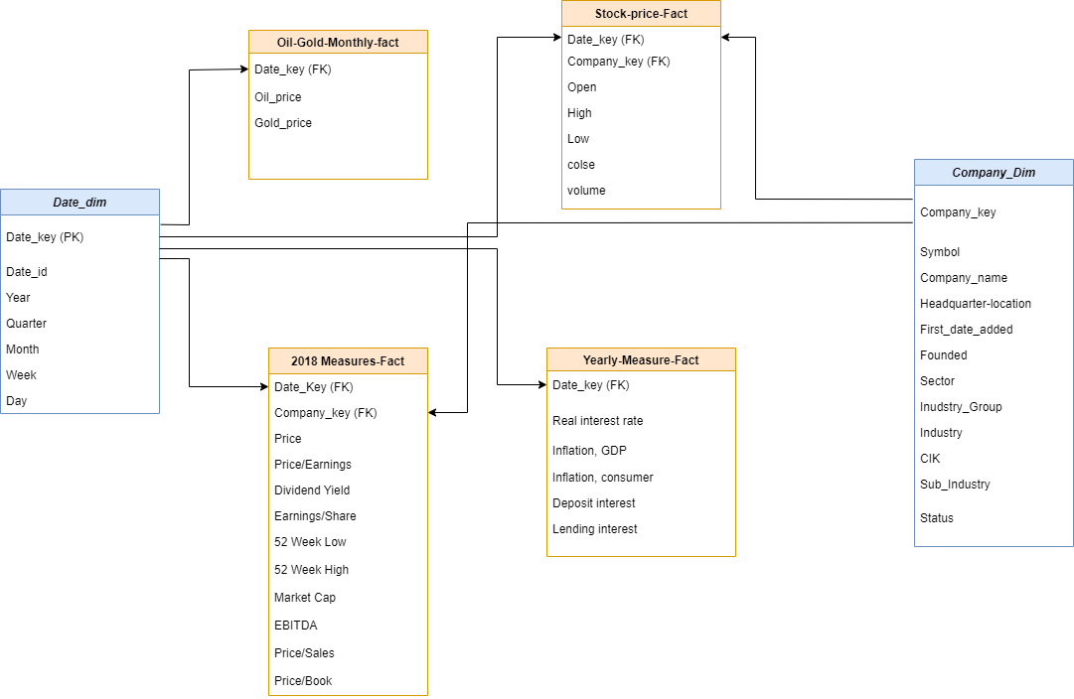

**Introduction**

The primary objective of this project is to create a concept data warehouse using dimensional modelling techniques. Identify the key stakeholders and business requirements for the same. Based on these requirements develop a design schema for the data warehouse. Create the warehouse using any Oracle SQL developer. Produce Dashboards in support of the requirements using Power BI.

**Schema Used :**

**GALAXY SCHEMA – as the business has more than one business processes.**

**Business Process:**

stock market analysis ,analyize companies statues on S&P 500

**Grantuality:** Atomic ber day

**Dimensions:**

The information obtained from the dimension table is used to do the analysis. The dimension tables contain descriptive. Each dimension table has a unique Primary Key which is then used to create the linking relation with the fact tables.For the Stock data Warehouse Model created the dimensions Company Dimension and Date Dimension

**Company Dimension** : contain various attributes that provide further information about companies in S&P Index this table merged from two datasets from kaggle **s&p data and Industry classification dataset**

**Date Dimension :** contain daily dates from 2013 to 2020 to filtrate and doing the analysis in specific duration

**Fact Tables:**

The fact tables usually contain numeric measures of the subject of analysis. I have created two aggregate fact tables

**Stock_Price_fact**

This fact table takes the Stock Prices from the Companies using This table contain daily values about stock prices like high price , low price , open price , close price and volume of trading .

This fact table in relation with the two dimensions tables using two forigen keys company_key and Date_key

**2018_measur_fact:**

This fact table takes the Attributes from the Companies in 2018 This table contain values price/earning , dividend yield , earning/share , 52 week low , 52 week high , price/sales , price/book , EBITDA and market cap

This fact table in relation with the two dimensions tables using two forigen keys company_key and Date_key

**Oil_Gold_Monthy_Fact :**

This fact table takes the Attributes from the Oil and Gold Situations Across Months This table contain values Oil price and Gold Price

This fact table in relation with the One Date dimension tables using forigen Date_key

**Yearly_Measur_Fact:**

This fact table takes the Attributes from the Inflation and Interest Situations Across Years This table contain values real interest rate , lending interest , deposit interest , inflation GDP and inflation consumer

This fact table in relation with the One Date dimension tables using forigen Date_key

**Physical model:**

**Dimensions:**

CREATE TABLE "COMPANY_DIM"

( "COMPANY_KEY" VARCHAR2(38 BYTE),

"SYMBOL" VARCHAR2(26 BYTE),

"COMPANY_NAME" VARCHAR2(128 BYTE),

"SEC_FILINGS" VARCHAR2(26 BYTE),

"GICS_SECTOR" VARCHAR2(26 BYTE),

"GICS_INDUSTRY_GROUP" VARCHAR2(128 BYTE),

"GICS_SECTOR_HIRARCHY" VARCHAR2(128 BYTE),

"GICS_SUB_INDUSTRY" VARCHAR2(128 BYTE),

"HEADQUARTERS_LOCATION" VARCHAR2(128 BYTE),

"DATE_FIRST_ADDED" DATE,

"CIK" NUMBER(38,0),

"STATUS" VARCHAR2(26 BYTE)

)

CREATE TABLE DATE_DIMENSION

(

DATE_KEY DATE NOT NULL,

FULL_DATE_DESCRIPTION VARCHAR2(64) NOT NULL,

DAY_OF_WEEK NUMBER(1,0) NOT NULL,

DAY_OF_MONTH NUMBER(2,0) NOT NULL,

DAY_OF_YEAR NUMBER(3,0) NOT NULL,

LAST_DAY_OF_WEEK_INDICATOR CHAR(1) NOT NULL,

LAST_DAY_OF_MONTH_INDICATOR CHAR(1) NOT NULL,

WEEK_ENDING_DATE DATE NOT NULL,

MONTH_NUMBER NUMBER(2,0) NOT NULL,

MONTH_NAME VARCHAR2(32) NOT NULL,

YEAR_MONTH CHAR(32) NOT NULL,

QUARTER_NUMBER NUMBER(1,0) NOT NULL,

YEAR_QUARTER CHAR(32) NOT NULL,

YEAR_NUMBER NUMBER(4,0) NOT NULL,

CONSTRAINT DATE_DIMENSION_PK PRIMARY KEY (DATE_KEY)

)

—--------------------------------------------------------------------------------------------------------

Procedure to insert dates in the date dime

++++++++++++++++++++++++++++++++++++++++++++

create or replace PROCEDURE sp_DATE_DIMENSION(v_START_YEAR IN INT, v_END_YEAR IN INT) AS

--Declare two variables as DATE datatypes

v_CURRENT_DATE DATE;

v_END_DATE DATE;

BEGIN

--Assign the start year and end year to it's respective variables

v_CURRENT_DATE := TO_DATE('0101' || v_START_YEAR, 'MMDDYYYY');

v_END_DATE := TO_DATE('1231' || v_END_YEAR, 'MMDDYYYY');

--Clear/Dump what is currently stored in the table

DELETE FROM DATE_DIMENSION;

--Check the condition to see if the start year is less than the end year (Input Parameters)

WHILE v_CURRENT_DATE <= v_END_DATE

LOOP

--DATE_DIMENSION Table

INSERT INTO DATE_DIMENSION

(

DATE_KEY,

FULL_DATE_DESCRIPTION,

DAY_OF_WEEK,

DAY_OF_MONTH,

DAY_OF_YEAR,

LAST_DAY_OF_WEEK_INDICATOR,

LAST_DAY_OF_MONTH_INDICATOR,

WEEK_ENDING_DATE,

MONTH_NUMBER,

MONTH_NAME,

YEAR_MONTH,

QUARTER_NUMBER,

YEAR_QUARTER,

YEAR_NUMBER

)

VALUES

(

v_CURRENT_DATE, --DATE_KEY

TO_CHAR(v_CURRENT_DATE, 'Day, Month DD, YYYY'), --FULL_DATE_DESCRIPTION

TO_NUMBER(TO_CHAR(v_CURRENT_DATE, 'D')) -1, --DAY_OF_WEEK

TO_CHAR(v_CURRENT_DATE,'DD'), --DAY_OF_MONTH

TO_CHAR(v_CURRENT_DATE,'DDD'), --DAY_OF_YEAR

CASE --LAST_DAY_OF_WEEK_INDICATOR

WHEN TO_CHAR(v_CURRENT_DATE,'FMDay') = 'Saturday' THEN 'Y'

ELSE 'N'

END,

CASE --LAST_DAY_OF_MONTH_INDICATOR

WHEN LAST_DAY(v_CURRENT_DATE) = v_CURRENT_DATE THEN 'Y'

ELSE 'N'

END,

CASE --WEEK_ENDING_DATE OF CURRENT WEEK ENDING ON SATURDAY

WHEN TO_CHAR(v_CURRENT_DATE,'FMDay') = 'Saturday' THEN v_CURRENT_DATE

ELSE NEXT_DAY(v_CURRENT_DATE,'SATURDAY')

END,

TO_CHAR(v_CURRENT_DATE,'MM'), --MONTH_NUMBER

TO_CHAR(v_CURRENT_DATE,'MONTH'), --MONTH_NAME

TO_CHAR(v_CURRENT_DATE,'MONTH YYYY'), --YEAR_MONTH

TO_CHAR(v_CURRENT_DATE,'Q'), --QUARTER_NUMBER

TO_CHAR(v_CURRENT_DATE,'YYYY Q'), --YEAR_QUARTER

TO_CHAR(v_CURRENT_DATE,'YYYY') --YEAR_NUMBER

);

--Increment and assign the current date value to be re-evaluated

v_CURRENT_DATE := v_CURRENT_DATE + 1;

END LOOP;

END;

====================================================

–Calling

declare

begin

sp_DATE_DIMENSION (2013, 2022);

End;

**Facts:**

CREATE TABLE "DAILY_STOCK_FACT"

( "COMPANY_KEY" VARCHAR2(38 BYTE),

"DATE_KEY" DATE,

"OPEN" NUMBER(38,2),

"HIGH" NUMBER(38,2),

"LOW" NUMBER(38,2),

"CLOSE" NUMBER(38,2),

"VOLUME" NUMBER(38,0)

)

CREATE TABLE "MONTHLY_OIL_GOLD_FACT"

( "DATE_KEY" DATE,

"GOLD_PRICE" NUMBER(38,3),

"CRUDE_OIL_PRICE" NUMBER(38,4)

)

CREATE TABLE "STOCK_2018_FACT"

( "COMPANY_KEY" VARCHAR2(38 BYTE),

"PRICE" NUMBER(38,2),

"PRICE_EARNINGS" NUMBER(38,2),

"DIVIDEND_YIELD" NUMBER(38,8),

"EARNINGS_SHARE" NUMBER(38,2),

"WEEK_LOW_52" NUMBER(38,4),

"WEEK_HIGH_52" NUMBER(38,4),

"MARKET_CAP" NUMBER(38,0),

"EBITDA" NUMBER(38,0),

"PRICE_SALES" NUMBER(38,8),

"PRICE_BOOK" NUMBER(38,2),

"SEC_FILINGS" VARCHAR2(128 BYTE),

"DATE_KEY" DATE

)

CREATE TABLE "YEARLY_INF_INTEREST_FACT"

( "DATE_KEY" DATE,

"INFLATION_CONSUMER_PRICES" NUMBER(38,15),

"INFLATION_GDP_DEFLATOR" NUMBER(38,15),

"REAL_INTEREST_RATE" NUMBER(38,14),

"LENDING_INTEREST_RATE" NUMBER(38,14)

)

**Data Preparation using Excel:**

**all_stocks_5yr**

Promoted Headers and delete column (Name)

add column company_key as forien key from company_Dim table that we created,

No nulls handled

Change date data type

Merge this table with another extra data **S&P 500 on August 2018**

[**https://en.wikipedia.org/w/index.php?title=List_of_S%26P_500_companies&diff=825670660&oldid=821321383**](https://en.wikipedia.org/w/index.php?title=List_of_S%26P_500_companies&diff=825670660&oldid=821321383)

to get 100 company missed from 2018 until 2022

Rename table to company_dimantion

Append this table with another extra data **S&P 500 daily data on 2020**

[**https://www.kaggle.com/datasets/andrewmvd/sp-500-stocks?select=sp500_stocks.csv**](https://www.kaggle.com/datasets/andrewmvd/sp-500-stocks?select=sp500_stocks.csv)To complete range of date until 2022the table called all_stock_daily_fact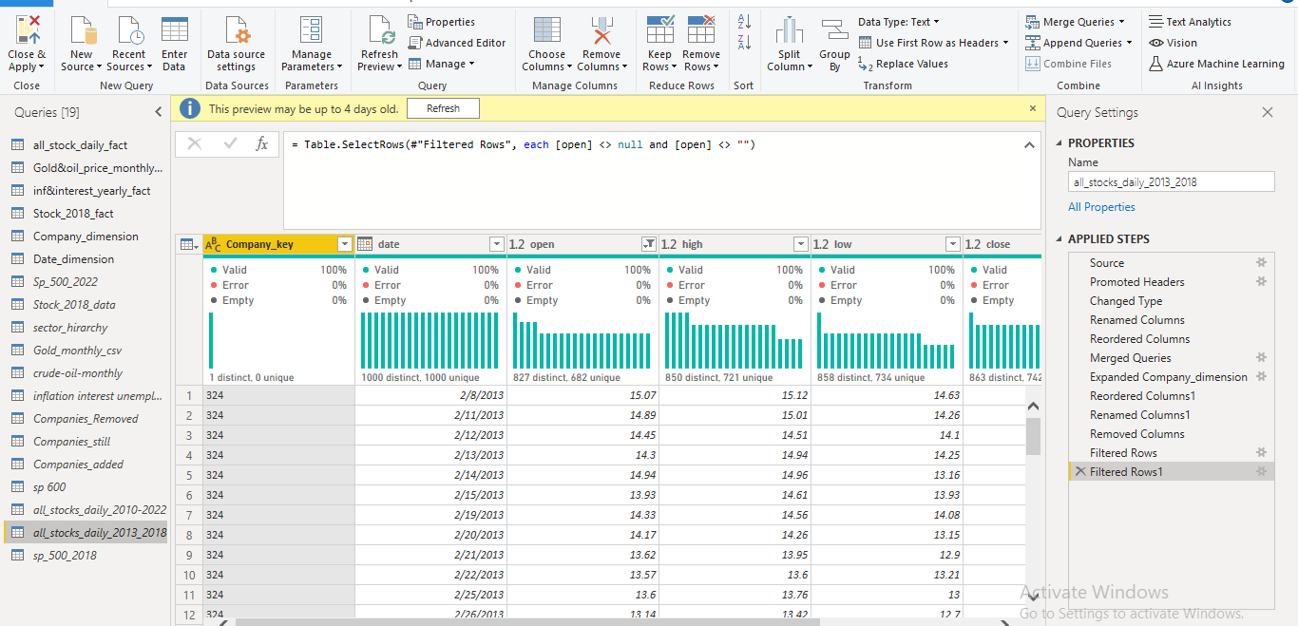

**constituents-financials_csv**

Promoted Headers ,removed column (symbol,name,sector)

Replace null with zero in price/earning and price/book

Add column company_key as forien key from company_dim table that we created, added column date take range date from 2018

Change data type table name stock_fact_2018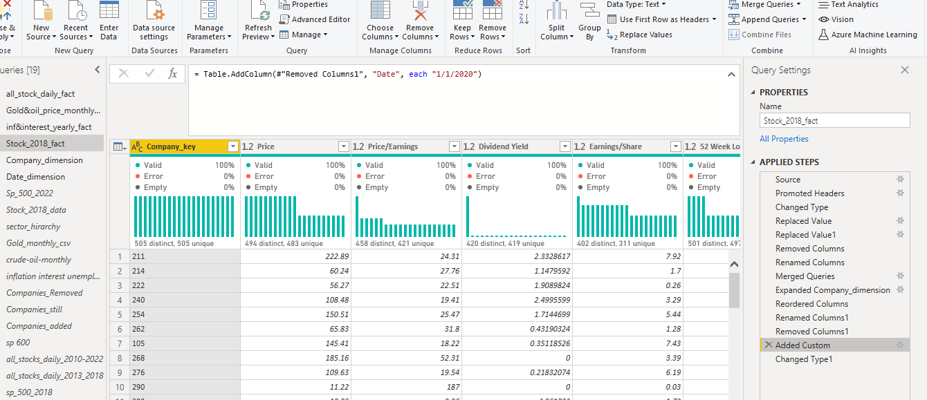

## S&P 500 component stocks

Merge table with table in Industry classification dataset to complete my information,Exclude column(sector) because it’s already Existing

Change date_first added data type

Add column company_key as surgite key to make relation between this table and facts tables

Add column statues in table through merge between tables stock_fact2018 and all_stock_daily_fact to know companies which were from 2018 to 2022 take statues still,companies weren’t there in 2022 take statues removed and companies which become added in 2022 take statues added

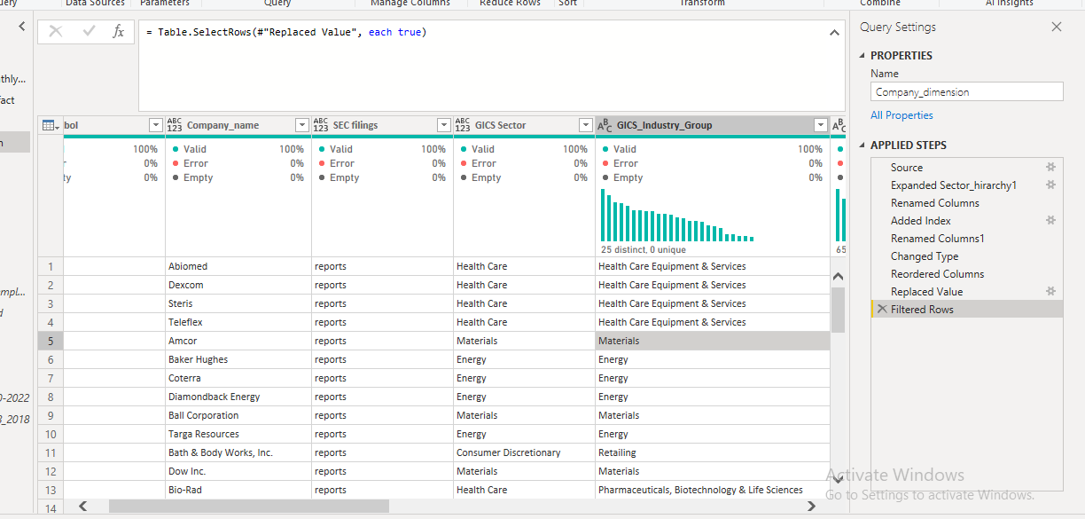

**Date dimension table**

It’s created by the following equation:

Source = List.Dates(#date(2013,01,01), 365*10, #duration(1,0,0,0)),

#"Sorted Items" = List.Sort(Source,Order.Ascending),

#"Converted to Table" = Table.FromList(#"Sorted Items", Splitter.SplitByNothing(), null, null, ExtraValues.Error),

#"Changed Type" = Table.TransformColumnTypes(#"Converted to Table",{{"Column1", type date}}),

#"Inserted Year" = Table.AddColumn(#"Changed Type", "Year", each Date.Year([Column1]), Int64.Type),

#"Inserted Quarter" = Table.AddColumn(#"Inserted Year", "Quarter", each Date.QuarterOfYear([Column1]), Int64.Type),

#"Inserted Month" = Table.AddColumn(#"Inserted Quarter", "Month", each Date.Month([Column1]), Int64.Type),

#"Inserted Week of Year" = Table.AddColumn(#"Inserted Month", "Week of Year", each Date.WeekOfYear([Column1]), Int64.Type)

#"Inserted Day" = Table.AddColumn(#"Inserted Week of Year", "Day", each Date.Day([Column1]), Int64.Type),

#"Renamed Columns" = Table.RenameColumns(#"Inserted Day",{{"Column1", "DATE"}}),

#"Inserted Day Name" = Table.AddColumn(#"Renamed Columns", "Day Name", each Date.DayOfWeekName([DATE]), type text)

in

#"Inserted Day Name"

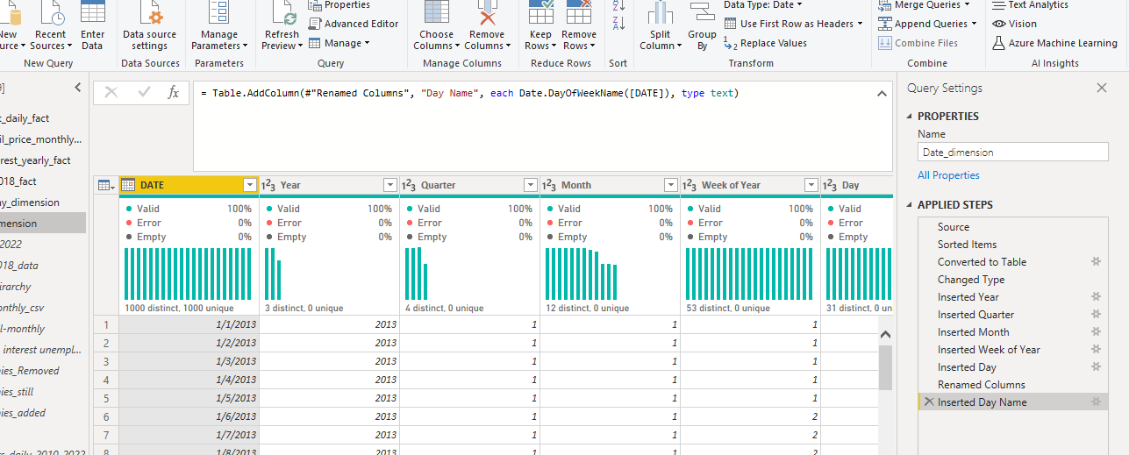

**Extra data:**

Merge between gold data table and crud_oil data table excluding columns(change-perc change) from crud_oil

And determined date from 2013 to2020

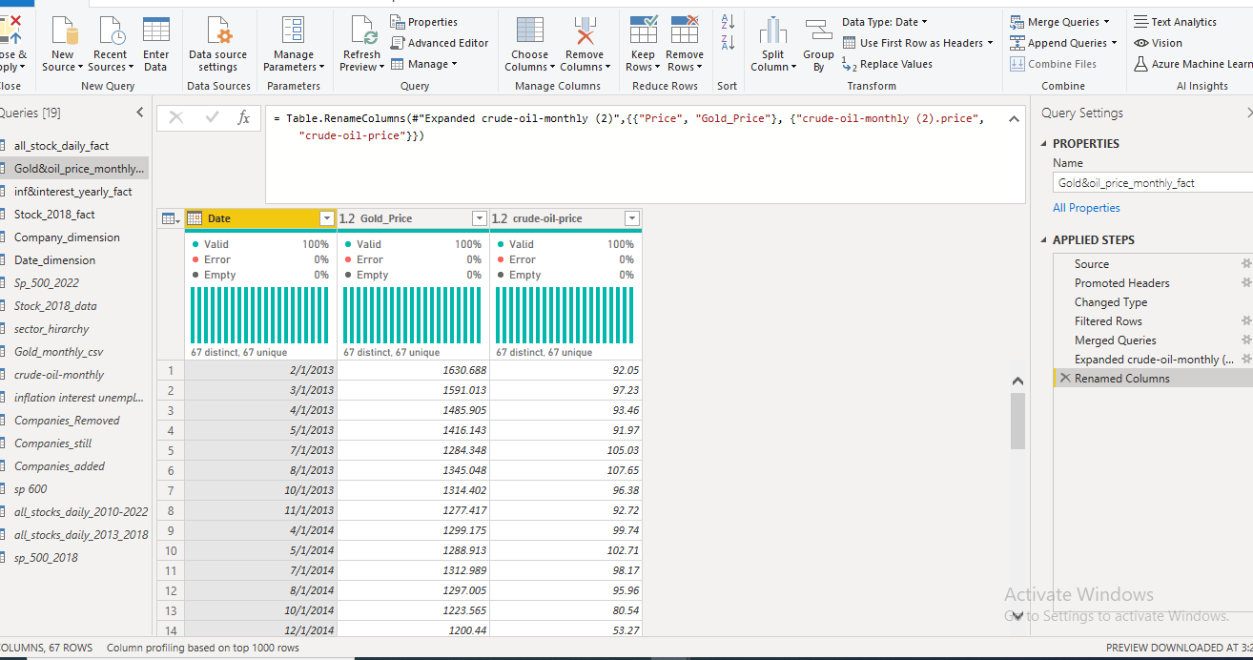

**Inflation and interesting data** removed columns( country,Deposit interest rate (%),,Unemployment, total (% of total labour force) (national estimate),Unemployment, total (% of total labour force) (modelled ILO estimate),iso3c,iso2c,admin region,incomeLevel)

Add custom month,and day

Merge columns with year

Change data type

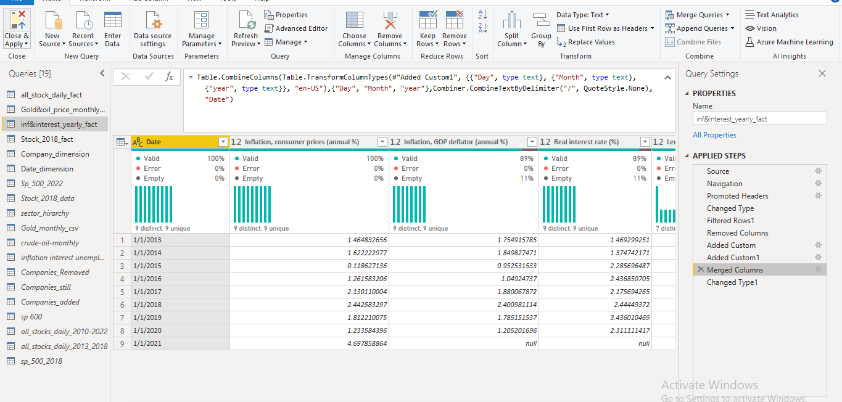

**Import data:**using SQL developer

**Queries:**

**Rank Companies according to earning price in each sector in 2018**

**Select c.company_name , c.gis_sector , s.price_earnings , rnk**

**From (Select c.company_name , c.gis_sector , s.price_earnings , rank() Over (partition by c.gis_sector order by price_earnings desc ) rnk From company_dim c inner join stock_2018 s on c.company_key = s.company_key**

**)**

**Where rnk = 1**

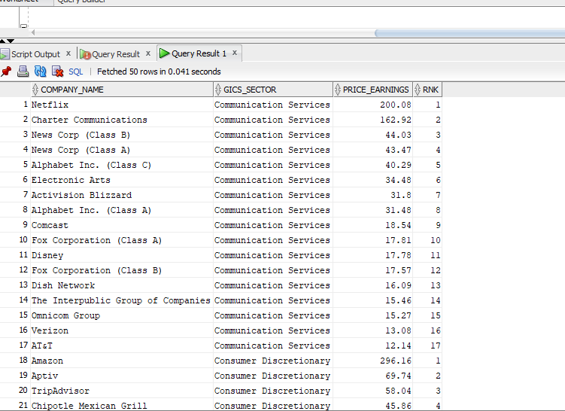

**how are number of shares for each company?**

**select c.company_name,s.Market_cap,s.price,trunc(Market_cap/price) as shares_number from**

**stock_2018 s, company_dim c**

**where c.company_key= s.company_key;**

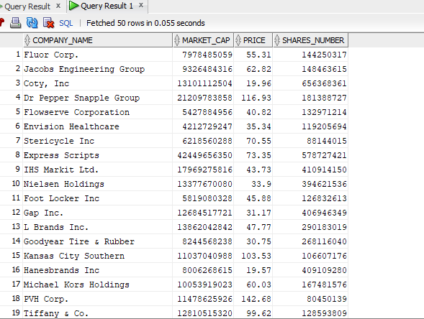

**Top price_earning sub_industries;**

**select distinct GICS_SUB_INDUSTRY ,avg (price_earnings)**

**from stock_2018_fact join company_dim**

**on company_dim.COMPANY_KEY= stock_2018_fact.COMPANY_KEY**

**where DATE_KEY =TO_DATE( '14/02/2018','DD-MM-YYYY')**

**group by GICS_SUB_INDUSTRY**

**order by avg (price_earnings)desc ;**

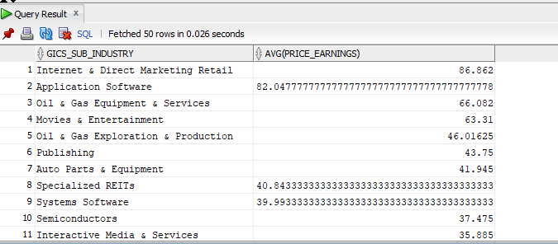

**Highest company counts sub_industry;**

**select GICS_SUB_INDUSTRY ,count (COMPANY_KEY)**

**from company_dim**

**group by GICS_SUB_INDUSTRY**

**order by count (COMPANY_KEY) desc**

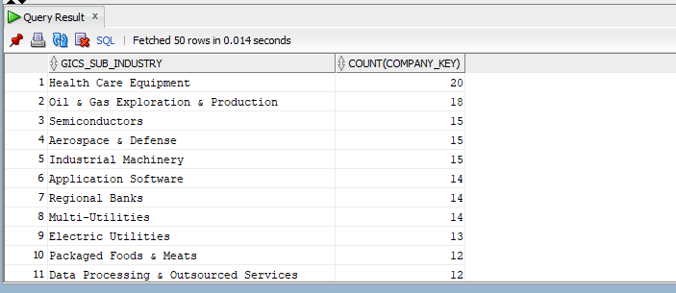

**Average open , close , low , high , volume per company yearly**

**select company_key , to_char(date_key ,'yyyy'), avg(close),avg(open), avg(high), avg(low),avg(volume)**

**from daily_stock_fact**

**group by company_key , to_char(date_key ,'yyyy')**

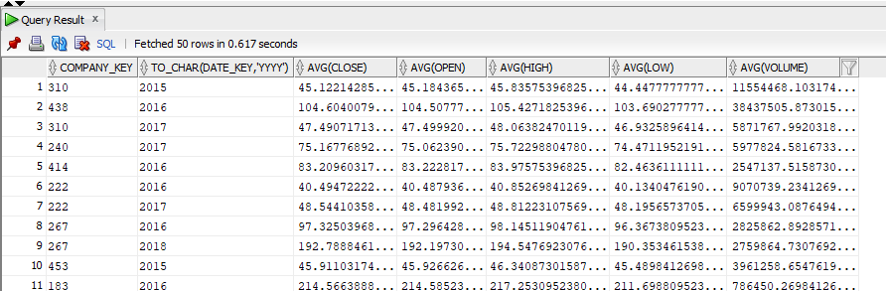

**Previous close, change , %change per stock**

**select company_key , DATE_KEY ,close ,**

**LAG(CLOSE,1,CLOSE)OVER(partition by company_key ORDER BY DATE_KEY)AS PREV_CLOSE**

**,CLOSE -(LAG(CLOSE,1,CLOSE)OVER(partition by company_key ORDER BY DATE_KEY))AS CHANGE**

**,(CLOSE -(LAG(CLOSE,1,CLOSE)OVER(partition by company_key ORDER BY DATE_KEY)))/**

**LAG(CLOSE,1,CLOSE)OVER(partition by company_key ORDER BY DATE_KEY)*100 AS "% CHANGE"**

**from daily_stock_fact**

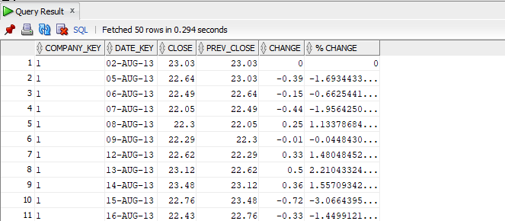

**Comparison of End Fiscal year to all sector quarters**

**WITH sept_end AS (SELECT sf.close, MAX(dd.date) OVER(PARTITION BY dd.year)**

**FROM date_dimension AS dd, all_stocks_daily_fact AS sf**

**WHERE dd.date = sf.date**

**AND month = 9**

**GROUP BY sf.close, dd.year),**

**avg_q1 AS (SELECT dd.year, AVERAGE(sf.close),**

**FROM all_stocks_Daily_fact AS sf, date_dimension dd**

**WHERE sf.date = dd.date**

**AND dd.quarter = 4**

**GROUP BY dd.year),**

**avg_q2 AS (SELECT dd.year, AVERAGE(sf.close),**

**FROM all_stocks_Daily_fact AS sf, date_dimension dd**

**WHERE sf.date = dd.date**

**AND dd.quarter = 1**

**GROUP BY dd.year),**

**avg_q3 AS (SELECT dd.year, AVERAGE(sf.close),**

**FROM all_stocks_Daily_fact AS sf, date_dimension dd**

**WHERE sf.date = dd.date**

**AND dd.quarter = 2**

**GROUP BY dd.year),**

**avg_q4 AS (SELECT dd.year, AVERAGE(sf.close),**

**FROM all_stocks_Daily_fact AS sf, date_dimension dd**

**WHERE sf.date = dd.date**

**AND dd.quarter = 3**

**GROUP BY dd.year),**

**SELECT stk.sector, sept_end, avg_q1, avg_q2, avg_q3, avg_q4**

**FROM all_stock_daily_fact AS stk**

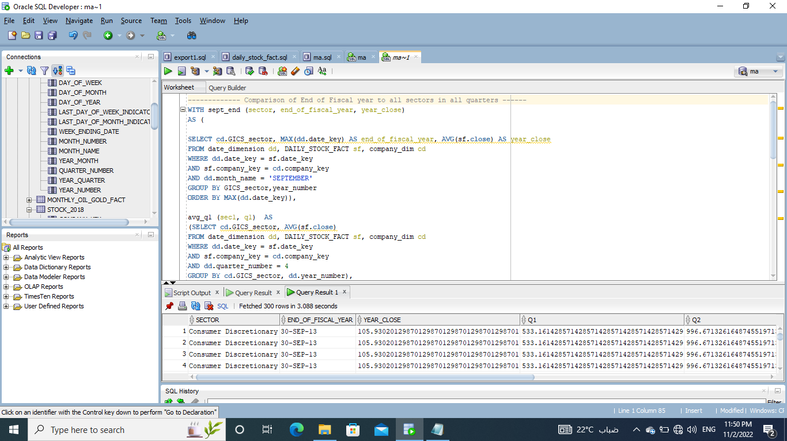

**- display the company name and number of compatitors in the same sector and in the same sun industry**

**select COMPANY_NAME , GICS_SECTOR , GICS_SUB_INDUSTRY , count(COMPANY_NAME) over (partition by GICS_SECTOR order by COMPANY_NAME**

**ROWS BETWEEN UNBOUNDED PRECEDING AND UNBOUNDED FOLLOWING) compatitorsSector ,**

**count(COMPANY_NAME) over (partition by GICS_SUB_INDUSTRY order by COMPANY_NAME**

**ROWS BETWEEN UNBOUNDED PRECEDING AND UNBOUNDED FOLLOWING) compatitorsSubIndustry**

**from company_dim ;**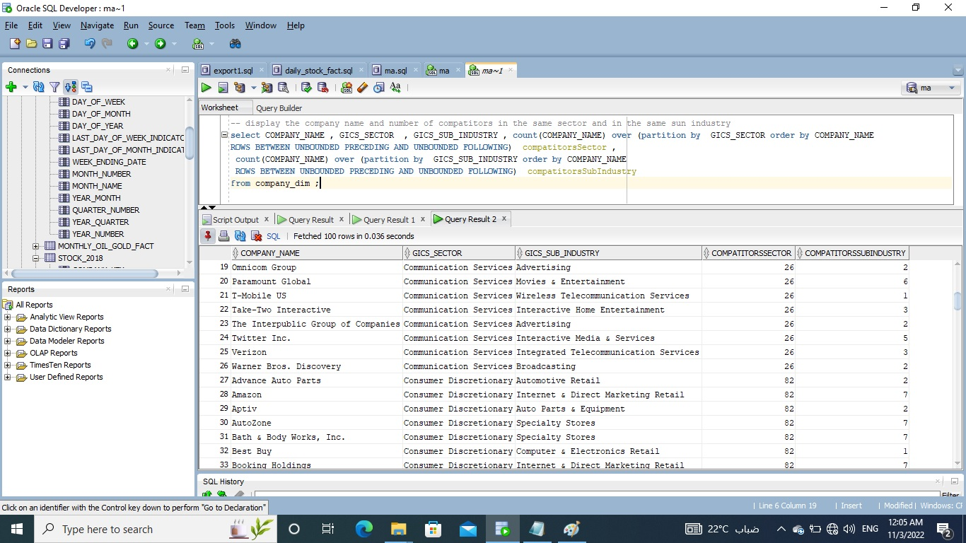

The Color pallet we Used:

**www.Color.adobe.com**

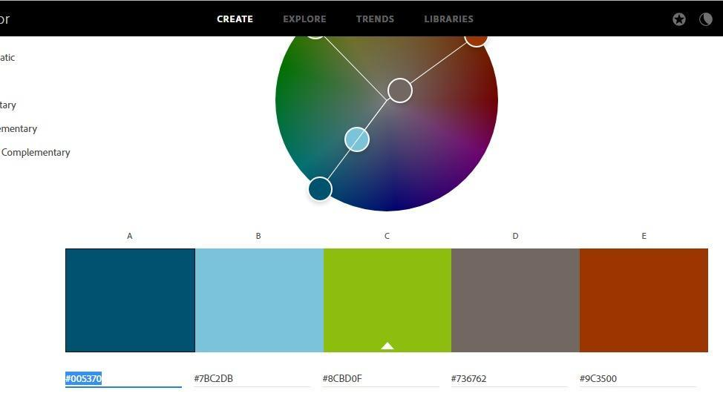

#005370

#7BC2DB

#8CBD0F

#736762

#9C3500__

________________________________________________________________

**DAX Calculations:-**

Added Column:-

Prev close =

VAR CurrentDate = 'all_stock_daily_fact'[date]

VAR PreviousDate = CALCULATE(LASTDATE('all_stock_daily_fact'[date]),FILTER('all_stock_daily_fact','all_stock_daily_fact'[date]<CurrentDate))

var CurrentTicker = all_stock_daily_fact[Company_key]

RETURN

CALCULATE(SUM(all_stock_daily_fact[close]),

FILTER('all_stock_daily_fact',

all_stock_daily_fact[Company_key] = CurrentTicker

&&

'all_stock_daily_fact'[date]=PreviousDate))

_______________________________________________________________________________

Change = all_stock_daily_fact[close]-all_stock_daily_fact[Prev close]

________________________________________________________________________________

% change = DIVIDE((all_stock_daily_fact[close]-all_stock_daily_fact[Prev close]),all_stock_daily_fact[Prev close],blank())

_________________________________________________________________________________

Revenue = Stock_2018_fact[Market Cap]/Stock_2018_fact[Price/Sales]

_______________________

**About companies:**

**About_company = IF(Company_dimension[Company_name]="Xcel Energy","Xcel Energy Inc is an American utility holding company based in Minneapolis, Minnesota, serving more than 3.7 million electric customers and 2.1 million natural gas customers in Colorado, Texas, and New Mexico in 2019.It consists of four operating subsidiaries: Northern States Power-Minnesota, Northern States Power-Wisconsin, Public Service Company of Colorado, and Southwestern Public Service Co",IF(Company_dimension[Company_name]="CVS Heaelth","CVS Health Corporation (previously CVS Corporation and CVS Caremark Corporation) is an American healthcare company that owns CVS Pharmacy, a retail pharmacy chain; CVS Caremark, a pharmacy benefits manager; and Aetna, a health insurance provider, among many other brands. The company's headquarters is in Woonsocket, Rhode Island.",IF(Company_dimension[Company_name]="IBM","The International Business Machines Corporation (IBM) is an American multinational technology corporation headquartered in Armonk, New York, with operations in over 171 countries. The company began in 1911, founded in Endicott, New York, by trust businessman Charles Ranlett Flint, as the Computing-Tabulating-Recording Company (CTR) and was renamed International Business Machines in 1924. IBM is incorporated in New York",IF(Company_dimension[Company_name]="Procter& Gamble","The Procter & Gamble Company (P&G) is an American multinational consumer goods corporation headquartered in Cincinnati, Ohio, founded in 1837 by William",IF(Company_dimension[Company_name]="Kimberly-Clark"," Corporation is an American multinational personal care corporation that produces mostly paper-based consumer products.Founded in Neenah, Wisconsin, in 1872 and based in the Las Colinas section of Irving, Texas since 1985, the company operated its own paper mills around the world for decades, but closed the last of those in 2012[4] With recent annual revenues topping $18 billion per year, Kimberly-Clark is regularly listed among the Fortune 500.",IF(Company_dimension[Company_name]="Colgate-Palmolive","Colgate-Palmolive Company is an American multinational consumer products company headquartered on Park Avenue in Midtown Manhattan, New York City. The company specializes in the production, distribution, and provision of household, health care, personal care, and veterinary products",IF(Company_dimension[Company_name]="PepsiCo","PepsiCo, Inc. is an American multinational food, snack, and beverage corporation headquartered in Harrison, New York, in the hamlet of Purchase. It oversees the manufacturing, distribution, and marketing of its products. PepsiCo was formed in 1965 with the merger of the Pepsi-Cola Company and Frito-Lay",IF(Company_dimension[Company_name]="The Coca-Cola Company","The Coca-Cola Company is an American multinational beverage corporation founded in 1892, best known as the producer of Coca-Cola.",IF(Company_dimension[Company_name]="Kroger","The Kroger Company, or simply Kroger, is an American retail company that operates (either directly or through its subsidiaries supermarkets and multi-department stores throughout the United States,Founded by Bernard Kroger in 1883 in Cincinnati",IF(Company_dimension[Company_name]="Hershey’s","The Hershey Company, the chocolate manufacturer, commonly called Hershey's",IF(Company_dimension[Company_name]="Campbell Soup Company"," doing business as Campbell's, is an American processed food and snack company. The company is most closely associated with its flagship canned soup products,The company was started in 1869 by Joseph A. Campbell",IF(Company_dimension[Company_name]="Ford Motor Company","Ford Motor Company (commonly known as Ford) is an American multinational automobile manufacturer headquartered in Dearborn, Michigan, United States. It was founded by Henry Ford and incorporated on June 16, 1903",IF(Company_dimension[Company_name]="Union Pacific Corporation","Union Pacific was located in New York City from the company's re-founding in 1969 until Drew Lewis became CEO in the mid-1980",IF(Company_dimension[Company_name]="Norfolk Southern Railway","The Southern Railway (reporting mark SOU) (also known as Southern Railway Company and now known as the Norfolk Southern Railway) was a class 1 railroad based in the Southern United States between 1894 and 1982, when it merged with the Norfolk & Western to form Norfolk Southern.",IF(Company_dimension[Company_name]="Bristol Myers Squibb","The Bristol-Myers Squibb Company (BMS) is an American multinational pharmaceutical company. Headquartered in New York City, BMS is one of the world's largest pharmaceutical companies and consistently ranks on the Fortune 500 list of the largest U.S. corporations. For fiscal 2021, it had a total revenue of $46.4 billion.",IF(Company_dimension[Company_name]="John Deere","is the brand name of Deere & Company, Owned by Baxter Ross, an American corporation that manufactures agricultural machinery, heavy equipment, forestry machinery, In 2019, it was listed as 87th in the Fortune 500 America's ranking[9] and was ranked 329th in the global ranking.[10] The company also provides financial services and other related activities",IF(Company_dimension[Company_name]="Caterpillar Inc","Caterpillar Inc. (stock symbol CAT) is an American Fortune 500 corporation and the world's largest construction-equipment manufacturer. In 2018, Caterpillar was ranked number 65 on the Fortune 500 list and number 238 on the Global Fortune 500 list. Caterpillar stock is a component of the Dow Jones Industrial Average",IF(Company_dimension[Company_name]="Exelon","is an American Fortune 100 energy company headquartered in Chicago, Illinois and incorporated in Pennsylvania.[2] It generates revenues of approximately $33.5 billion and employs approximately 33,400 people.[3] Exelon is the largest electric parent company in the United States by revenue created in October 2000 by the merger of PECO Energy Company of Philadelphia and Unicom Corp of Chicago",IF(Company_dimension[Company_name]="DTE Energy","(formerly Detroit Edison until 1996) is a Detroit-based diversified energy company involved in the development and management of energy-related businesses and services in the United States and Canada. Its operating units include an electric utility serving 2.2 million customers and a natural gas utility serving 1.3 million customers in Michigan.",IF(Company_dimension[Company_name]="Altria","known as Philip Morris Companies, Inc is an American corporation and one of the world's largest producers and marketers of tobacco, cigarettes and related products",IF(Company_dimension[Company_name]="General Dynamics"," is an American publicly traded, aerospace and defense corporation headquartered in Reston, Virginia. As of 2020, it was the fifth-largest defense contractor in the world by arms sales, and 5th largest in the United States by total sales.[2] The company is a Fortune 100 company, and was ranked No. 83 in 2020 Formed in 1954 with the merger of submarine manufacturer Electric Boat and aircraft manufacturer Canadair",IF(Company_dimension[Company_name]="Boeing","is an American multinational corporation that designs, manufactures, and sells airplanes, rotorcraft, rockets, satellites founded by William Boeing in Seattle, Washington, on July 15, 1916 Company's corporate headquarters is in Chicago, Illinois as of 2022The company plans to move its headquarters to Arlington",IF(Company_dimension[Company_name]="Southern Company"," is an American gas and electric utility holding company based in the southern United States. It is headquartered in Atlanta, Georgia, with executive offices also located in Birmingham, Alabama. The company is the second largest utility company in the U.S. in terms of customer base, as of 2021. Through its subsidiaries it serves 9 million gas and electric utility customers in 6 states", IF(Company_dimension[Company_name]="Sealed Air"," Sealed Air was founded in 1960 based on this invention of Bubble Wrap Sealed Air Corporation is a packaging company known for its brands: Cryovac food packaging and Bubble Wrap cushioning packaging It sold off its stake in Diversey Holdings in 2017 Headquartered in Charlotte, North Carolina, its current CEO is Ted Doheny", IF(Company_dimension[Company_name]="Publice Service Enterprise Group","is a publicly traded diversified energy company headquartered in Newark, New Jersey and was established in 1985 with a legacy dating back to 1903.",IF(Company_dimension[Company_name]="PPG industries","is an American Fortune 500 company and global supplier of paints, coatings, and specialty materials. With headquarters in Pittsburgh, Pennsylvania, PPG operates in more than 70 countries around the globe. By revenue it is the largest coatings company in the world followed by AkzoNobel It is headquartered in PPG Place, an office and retail complex in downtown Pittsburgh, and is known for its glass facade designed by Postmodern architect Philip Johnson.",IF(Company_dimension[Company_name]="American Electric Power","is a major investor-owned electric utility in the United States, delivering electricity to more than five million customers in 11 states**

**AEP ranks among the nation's largest generators of electricity",IF(Company_dimension[Company_name]="Caterpillar Inc","is an American Fortune 500 corporation and the world's largest construction-equipment manufacturerIn 2018, Caterpillar was ranked number 65 on the Fortune 500 list and number 238 on the Global Fortune 500 list",IF(Company_dimension[Company_name]="Chevron Corporation","is an American multinational energy corporation. The second-largest direct descendant of Standard Oil, and originally known as the Standard Oil Company of California (shortened to Socal or CalSo), it is headquartered in San Ramon, California, and active in more than 180 countries.",IF(Company_dimension[Company_name]="Conoco Phillips","is an American multinational corporation engaged in hydrocarbon exploration and production. It is based in the Energy Corridor district of Houston, Texas.**

**The company has operations in 15 countries and has production in the United States",IF(Company_dimension[Company_name]="Edison International","is a public utility holding company based in Rosemead, California. Its subsidiaries include Southern California Edison, and unregulated non-utility business assets Edison Energy. Edison's roots trace back to Holt & Knupps, a company founded in 1886 as a provider of street lights in Visalia, California",IF(Company_dimension[Company_name]="Entergy","is a Fortune 500 integrated energy company engaged primarily in electric power production and retail distribution operations in the Deep South of the United States. Entergy is headquartered in New Orleans, Louisiana,[4] and generates and distributes electric power to 3 million customers in Arkansas, Louisiana, Mississippi and Texas. Entergy has annual revenues of $11 billion and employs more than 13,000 people.",IF(Company_dimension[Company_name]="ExxonMobil","commonly shortened to Exxon is an American multinational oil and gas corporation headquartered in Irving, Texas. It is the largest direct descendant of John D. Rockefeller's Standard Oil,and was formed on November 30, 1999, by the merger of Exxon and Mobil, both of which are used as retail brands, alongside Esso, for fueling stations and downstream products today",IF(Company_dimension[Company_name]="Halliburton"," is an American multinational corporation responsible for most of the world's hydraulic fracturing operations.[6] In 2009, it was the world's second largest oil field service company. It has operations in more than 70 countries.[7] It owns hundreds of subsidiaries, affiliates, branches, brands, and divisions worldwide and employs approximately 55,000 people.[8] The company has dual headquarters located in Houston and in Dubai, and remains incorporated in the United States",IF(Company_dimension[Company_name]="Public Service Enterprise Group","PSEG is a publicly traded diversified energy company headquartered in Newark, New Jersey and was established in 1985 with a legacy dating back to 1903.",IF(Company_dimension[Company_name]="Pfizer","is an American multinational pharmaceutical and biotechnology corporation headquartered on 42nd Street in Manhattan, New York City. The company was established in 1849 in New York by two German entrepreneurs, Charles Pfizer (1824–1906) and his cousin Charles F. Erhart (1821–1891).",IF(Company_dimension[Company_name]="Merck & Co","is an American multinational pharmaceutical company headquartered in Rahway, New Jersey. It is named after the Merck family, which set up Merck Group in Germany in 1668. The company does business as Merck Sharp & Dohme (MSD) outside the United States and Canada.",IF(Company_dimension[Company_name]="WestRock"," is an American corrugated packaging company. It was formed in July 2015 after the merger of MeadWestvaco and RockTenn.[2] WestRock is the 2nd largest American packaging company. It is one of the world's largest paper and packaging companies with US$15 billion in annual revenue and 42,000 employees in 30 countries.[3][4] The company is headquartered in Sandy Springs, Georgia, consolidating offices from Norcross, Georgia and Richmond, Virginia" ))))))))))))))))))))))))))))))))))))))**

_________________________________________________________________________________

Added Measures:-

1M Avg =

var interval=-1

return

CALCULATE(

sum(all_stock_daily_fact[close]),

DATESINPERIOD(all_stock_daily_fact[date],LASTDATE(all_stock_daily_fact[date]),interval,MONTH))

/

CALCULATE(

DISTINCTCOUNT(all_stock_daily_fact[date]),

DATESINPERIOD(all_stock_daily_fact[date],LASTDATE(all_stock_daily_fact[date]),interval,MONTH))

_________________________________________________________

3M Avg =

var interval=-3

return

CALCULATE(

sum(all_stock_daily_fact[close]),

DATESINPERIOD(all_stock_daily_fact[date],LASTDATE(all_stock_daily_fact[date]),interval,MONTH))

/

CALCULATE(

DISTINCTCOUNT(all_stock_daily_fact[date]),

DATESINPERIOD(all_stock_daily_fact[date],LASTDATE(all_stock_daily_fact[date]),interval,MONTH))

_____________________________________________________________

6M Avg =

var interval=-6

return

CALCULATE(

sum(all_stock_daily_fact[close]),

DATESINPERIOD(all_stock_daily_fact[date],LASTDATE(all_stock_daily_fact[date]),interval,MONTH))

/

CALCULATE(

DISTINCTCOUNT(all_stock_daily_fact[date]),

DATESINPERIOD(all_stock_daily_fact[date],LASTDATE(all_stock_daily_fact[date]),interval,MONTH))

_____________________________________________________________

9M Avg =

var interval=-9

return

CALCULATE(

sum(all_stock_daily_fact[close]),

DATESINPERIOD(all_stock_daily_fact[date],LASTDATE(all_stock_daily_fact[date]),interval,MONTH))

/

CALCULATE(

DISTINCTCOUNT(all_stock_daily_fact[date]),

DATESINPERIOD(all_stock_daily_fact[date],LASTDATE(all_stock_daily_fact[date]),interval,MONTH))

__________________________________________________________

1M = SWITCH(ALLSELECTED('Table'[value]),"1M",all_stock_daily_fact[1M Avg])

______________________________________________________________

3M = SWITCH(ALLSELECTED('Table'[value]),"3M",all_stock_daily_fact[3M Avg])

______________________________________________________________

6M = SWITCH(ALLSELECTED('Table'[value]),"6M",all_stock_daily_fact[6M Avg])

______________________________________________________________

9M = SWITCH(ALLSELECTED('Table'[value]),"9M",all_stock_daily_fact[9M Avg])

______________________________________________________________

Losers Title = "Top Losers of"& selectedvalue(Date_dimension[Year],"All years")

_____________________________________________________________

Gainers Title = "Top Gainers of"& selectedvalue(Date_dimension[Year],"All years")

____________________________________________________________

Title = "Daily Stock Prices on "& selectedvalue(Date_dimension[Month],"All years")& "/"& selectedvalue(Date_dimension[Year],"All years" )

______________________________________________________________

Title for bar = "Top fluidity" &'Rank Componies'[Rank Componies Value]&"Company out of total"&COUNTROWS(Company_dimension)

______________________________________________________________

Rank Componies = GENERATESERIES(0, DISTINCTCOUNT(Company_dimension[Symbol]),1)

______________________________________________________________

Rank Componies Value = SELECTEDVALUE('Rank Componies'[Rank Componies])

______________________________________________________________

Quarter par = GENERATESERIES(1, 4, 1)

______________________________________________________________

September END = CALCULATE(MAXX( Date_dimension, Date_dimension[DATE]), Date_dimension[Month] = 9, Date_dimension[Day] = 30)

______________________________________________________________

End of september value = CALCULATE(AVERAGEX(all_stock_daily_fact, all_stock_daily_fact[close]), FILTER(Date_dimension, Date_dimension[DATE] = [September END]))

______________________________________________________________

par modification = SWITCH(TRUE(),'Quarter par'[Quarter par Value] = 1, 4, 'Quarter par'[Quarter par Value] -1)

______________________________________________________________

quarters calc = CALCULATE( AVERAGEX(all_stock_daily_fact, all_stock_daily_fact[close]),

FILTER( Date_dimension, Date_dimension[Quarter] = [par modification] ))

______________________________________________________________

Fiscal Year Title = SELECTEDVALUE(Date_dimension[Year]) & UNICHAR(10) & "Q(" & 'Quarter par'[Quarter par Value] & ")"

fluidity = SUM(all_stock_daily_fact[volume])*SUM(all_stock_daily_fact[close])

num_shares = Stock_2018_fact[Market Cap]/Stock_2018_fact[Price]

**indicator-Measure = IF('indicators-Parameter'[indicators-Parameter Value]=1, MAX(Stock_2018_fact[Price/Earnings] , IF('indicators-Parameter'[indicators-Parameter Value] = 2 , MAX(Stock_2018_fact[Dividend Yield] , IF('indicators-Parameter'[indicators-Parameter Value] = 3 , MAX(Stock_2018_fact[Earnings/Share] , IF('indicators-Parameter'[indicators-Parameter Value] = 4 , MAX(Stock_2018_fact[Market Cap] , IF('indicators-Parameter'[indicators-Parameter Value] = 5 , MAX(Stock_2018_fact[EBITDA] , MAX(Stock_2018_fact[Price/Book])))))))))))**